TEST LOG FORM | Test Log No: 8
Test ID: SE-N17-008 | Test Date: 30/01/2013
Tester: Tom | Group: 17
Version When Tested:
Test Passed? (Y/N): Y
Passed Testing 1st[X],2nd[ ],3rd[ ],4th[ ] time.
Other…………
Description of test: Register a new user using an existing username.

Proof of testing:
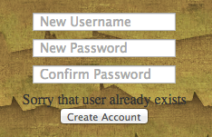

Comments: Test was successful on first attempt.
The following section only applies if the test failed and changes needed to be made. If change need to be made a change control form needs to be completed documenting this. The details of that form also need to be highlighted below.
Change Control Number:
Description of changes made:

